Erich Viebrock

ECPE 174

Pre Lab #4

**State Machine Diagram:**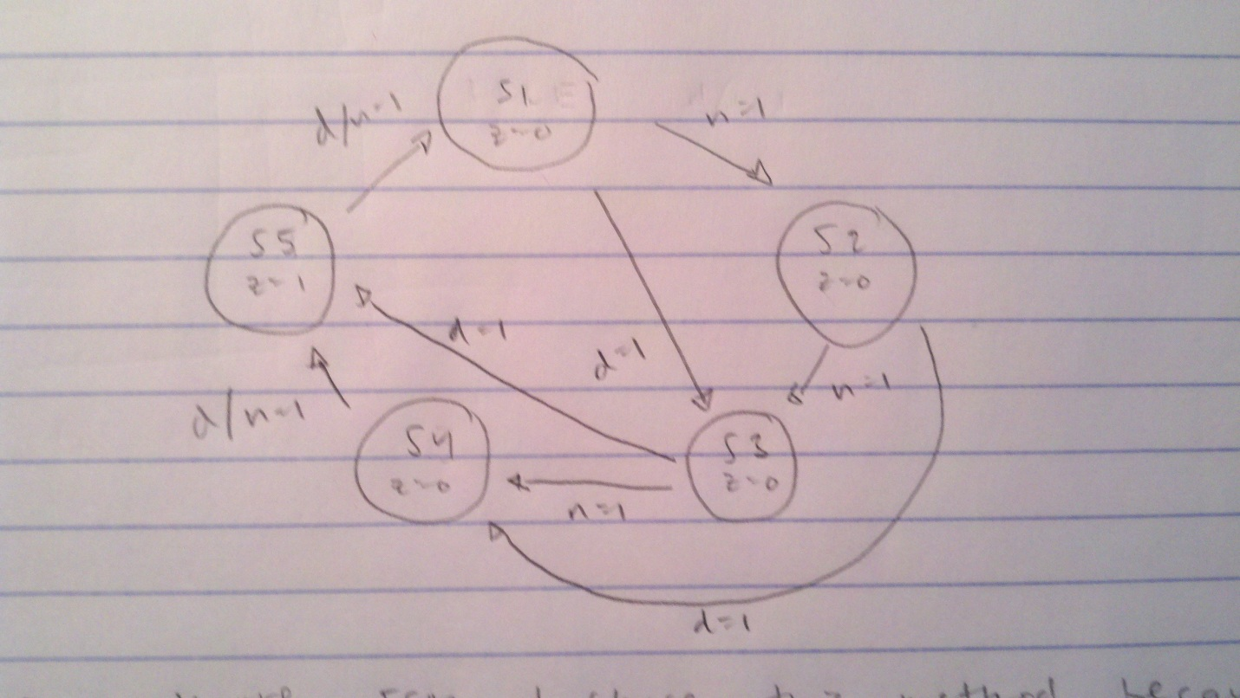

A Moore FSM was used because this seems like the simplest way to design the vending machine.

**VHDL:**

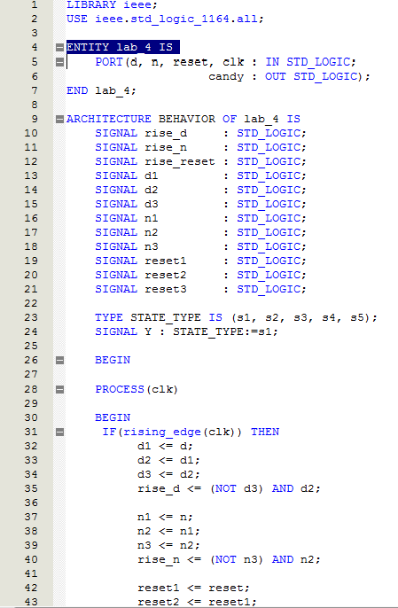

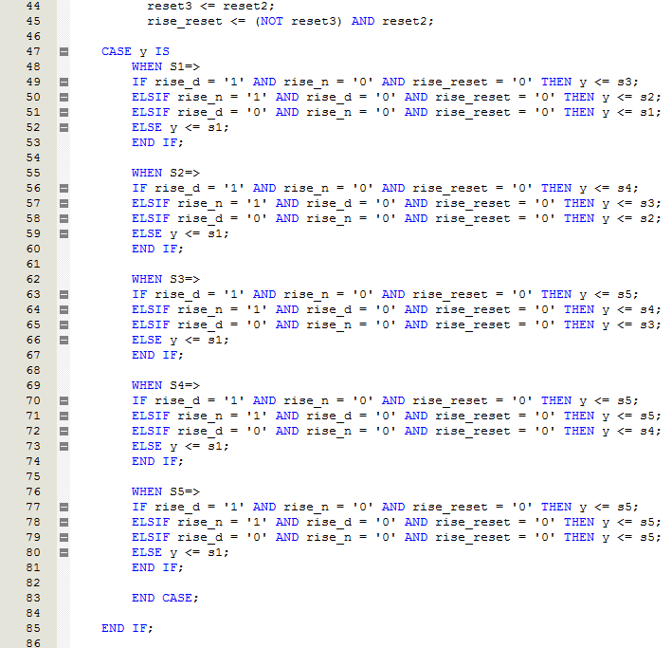

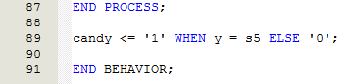

**Waveform Editor:**

